Data Handling and Visualization (DSA06)
Name: Prasanna M Reg. No: 1925260244
Set 22: Time Series Analysis
Question 1. In R, create a time series line chart to visualize the trend in monthly sales. Label the axes and title the chart.
Program (R):
sales <- data.frame(Month = c("January","February","March","April","May"),
Sales = c(15000,18000,22000,20000,23000))
sales_ts <- ts(sales$Sales, start = c(1, 1), frequency = 12) # monthly time series
plot(sales_ts, type = "o", pch = 19, col = "blue", xaxt = "n",
main = "Monthly Sales Trend", xlab = "Month", ylab = "Sales ($)")
axis(1, at = time(sales_ts), labels = sales$Month)
Output:
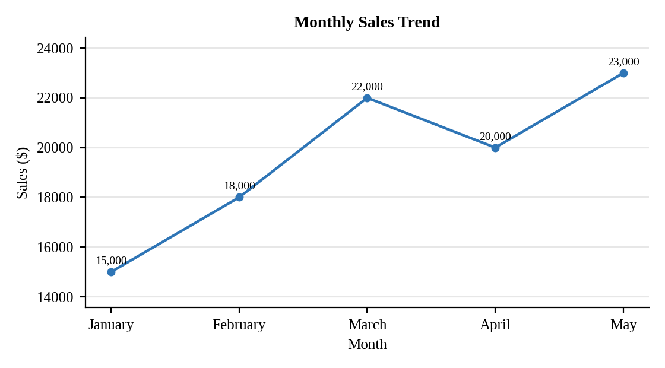
Interpretation:
Sales rose from 15000 in January to 22000 in March, dipped to 20000 in April and reached the highest value of 23000 in May. Overall growth is 53.3% over the five months, so the trend is upward.

Question 2. In R, generate a scatter plot to analyze the relationship between advertising budget and monthly sales. Explain any insights.
Assumed data: Advertising budget is not given in the dataset, so sample monthly budgets of 2000, 2500, 3200, 2800 and 3500 dollars are used.
Program (R):
sales$Ad_Budget <- c(2000, 2500, 3200, 2800, 3500)
library(ggplot2)
ggplot(sales, aes(x = Ad_Budget, y = Sales)) +
geom_point(size = 3, colour = "steelblue") +
geom_smooth(method = "lm", se = FALSE, colour = "red", linetype = "dashed") +
geom_text(aes(label = Month), vjust = -1, size = 3) +
labs(title = "Advertising Budget vs Monthly Sales",
x = "Advertising Budget ($)", y = "Monthly Sales ($)") +
theme_minimal()
cor(sales$Ad_Budget, sales$Sales)
Output:
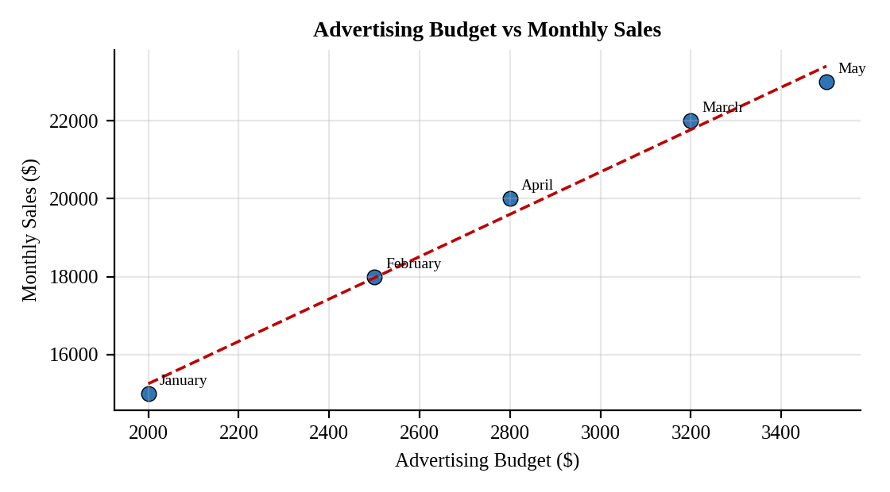
Interpretation:
The points rise from lower left to upper right with a correlation of r = 0.99, a strong positive relationship. The fitted line suggests about 5.4 dollars of extra sales for every extra dollar of advertising. This shows association, not proof of cause, and five points are a small sample.

Question 3. In Tableau, build a dashboard combining a line chart showing sales trend and a pie chart displaying the distribution of sales across products.
Assumed data: The dataset has no product field, so a Product column is added with total sales split 40% Product A, 35% Product B and 25% Product C (39200, 34300 and 24500 dollars).
Procedure (Tableau):
1. Open Tableau, click Connect, choose Text file / Microsoft Excel, select "Monthly_Sales_Data.csv" and open Sheet 1.
2. Sheet 1 (Line): Columns = Month (discrete); Rows = SUM(Sales); mark type = Line with circles; add labels and a title.
3. Sheet 2 (Pie): mark type = Pie; Color = Product; Angle = SUM(Sales); Label = Product and Percent of Total.
4. Click New Dashboard, name it "Sales Trend Dashboard", set Size to Automatic and drag the sheets onto the canvas.
5. Select each chart and click the "Use as Filter" icon so that clicking a mark filters the other sheets; keep tooltips enabled.
6. Add a title to every sheet, adjust labels and colours, and save the workbook (File > Save As, .twbx).

Output:
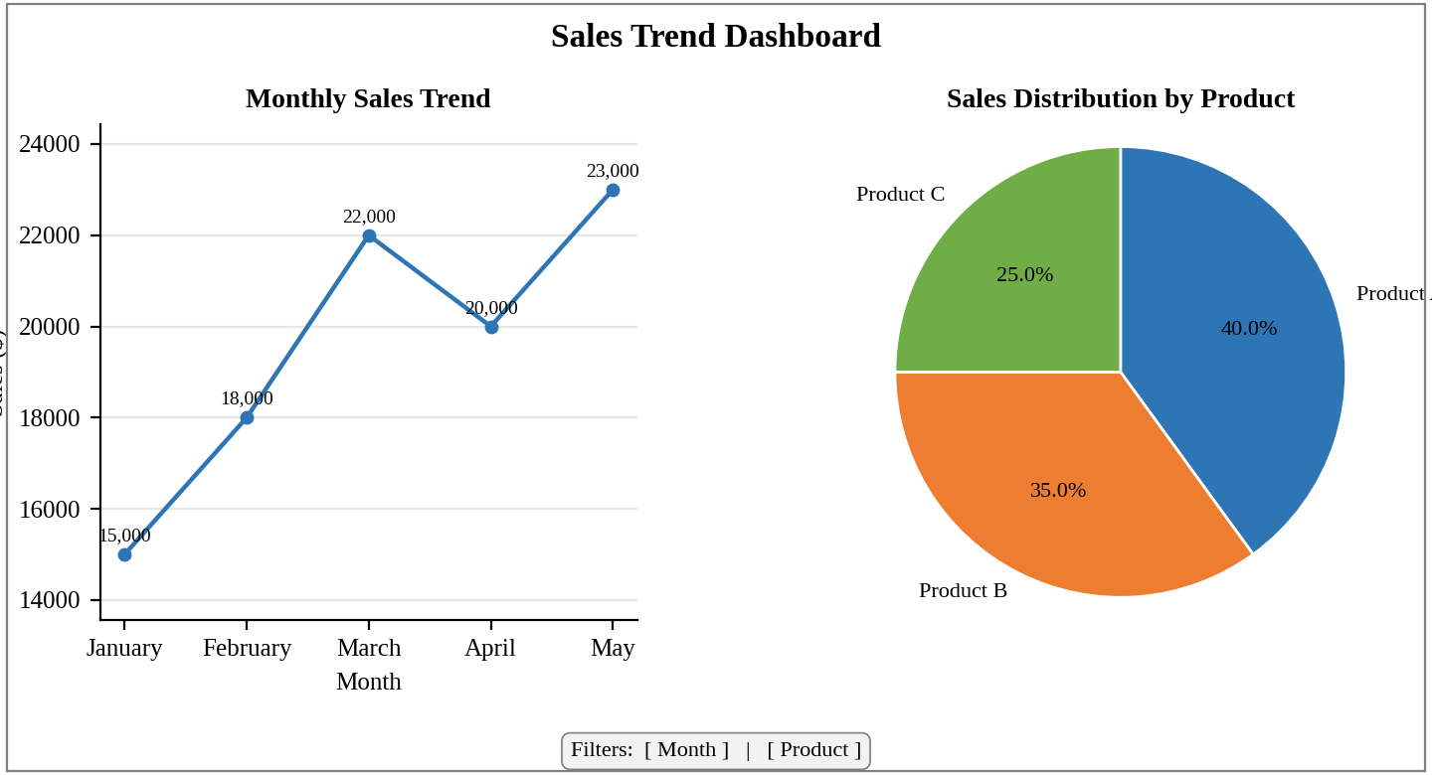
Dashboard layout (preview of the Tableau output).
Interpretation:
The line chart shows the upward trend with a dip in April, and the pie chart shows Product A contributing 40% of the 98000 dollars total, followed by Product B (35%) and Product C (25%). Clicking a pie slice filters the line chart to that product.

Question 4. In R, create an autocorrelation plot to identify seasonality in the time series data.
Program (R):
sales_ts <- ts(c(15000,18000,22000,20000,23000), start = c(1, 1), frequency = 12)
acf(sales_ts, main = "Autocorrelation of Monthly Sales", lag.max = 4)
Output:
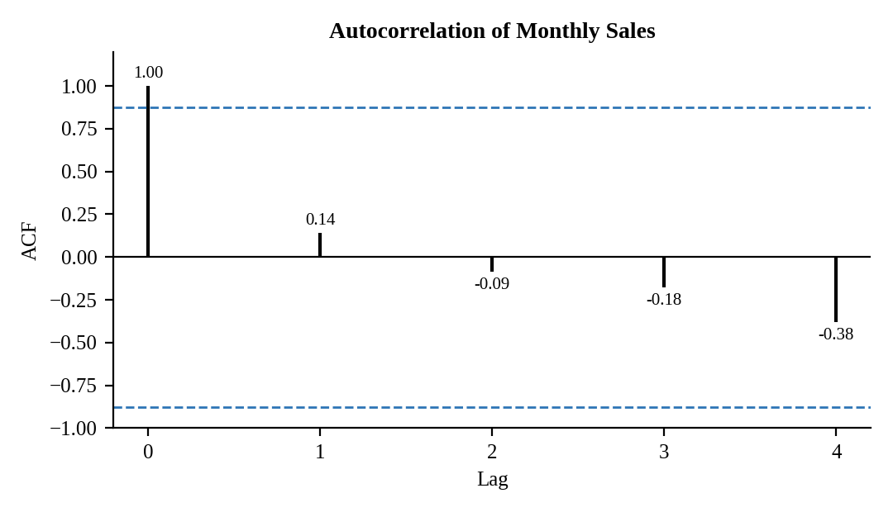
Interpretation:
The lag-1 autocorrelation is weak (0.14) and the values turn negative from lag 2 onwards (-0.09, -0.18 and -0.38). Every bar lies inside the dashed 95% limits (about ±0.88), so none is significantly different from zero.
There are no repeating peaks at a fixed lag, so the plot gives no evidence of seasonality; the drift to negative values at longer lags reflects the upward trend. With only five months the test has very little power, and at least two full years of monthly data are needed to identify a seasonal pattern.

